Author: Alyssa Pereslete

Last Updated: 3/10/19

Estimated time: 2 hours

**Materials:**

* Gloves
* Culture flasks
* 12 bead blast tubes
* 12 1.5ml tubes (if it is **Wednesday**)
* Deionized Water
* 70% Ethanol
* Micro-pipette (1ml max)
* Micro-pipette (2-20µL)
* Kim wipes
* Hemocytometer
* Microscope
* Counter

1. Wipe down bench with ethanol. Label 12 bead blast tubes with species, treatment, and flask number (ex: Oc9 C1 = Oculina control flask 1).
   1. **If wednesday,** label an additional 12 1.5-mL tubes for fluorescence. Also for chlorophyll extractions (**wednesday**), set the centrifuge to **4℃** because it will take time to lower its internal temperature.
2. Take out all 6 flasks from either control or variable incubator (control is the Right incubator if facing, closest to plate reader. Variable incubator is next to fume hood). I generally keep the flasks in the same order they were in the incubator so I can easily rotate/shift them when I put them back.
3. **Wipe the 100-1ml micropipette with ethanol in between every aliquot.** 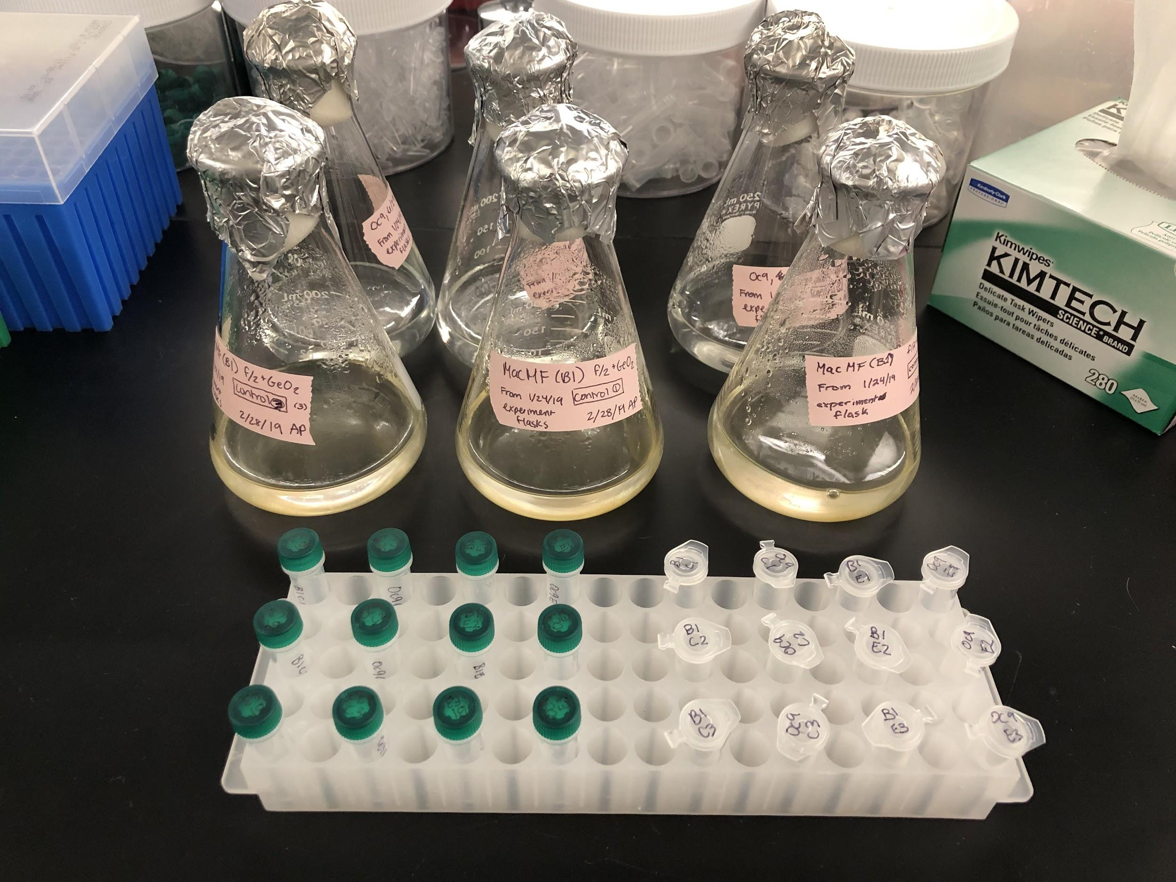
4. Remove foil and sponge, making sure you use the foil to hold the sponge. Do not turn sponge over.
5. If needed, backpipette any dense culture stuck to the bottom before swirling. Swirl flask for ~10 seconds.
6. While culture is still moving, take 1mL aliquot. Repeat for all 12 flasks.
   1. Take 1mL aliquots for the 12 1.5-ml tubes for fluorescence at the same time. Place all 12 aliquots in white box (SYM TVE FLUORESCENCE) to keep in darkness while counts are being conducted. Once counts are complete, see fluorescence protocol.
7. At the microscope, vortex each aliquot 4x for ~1 second pulses.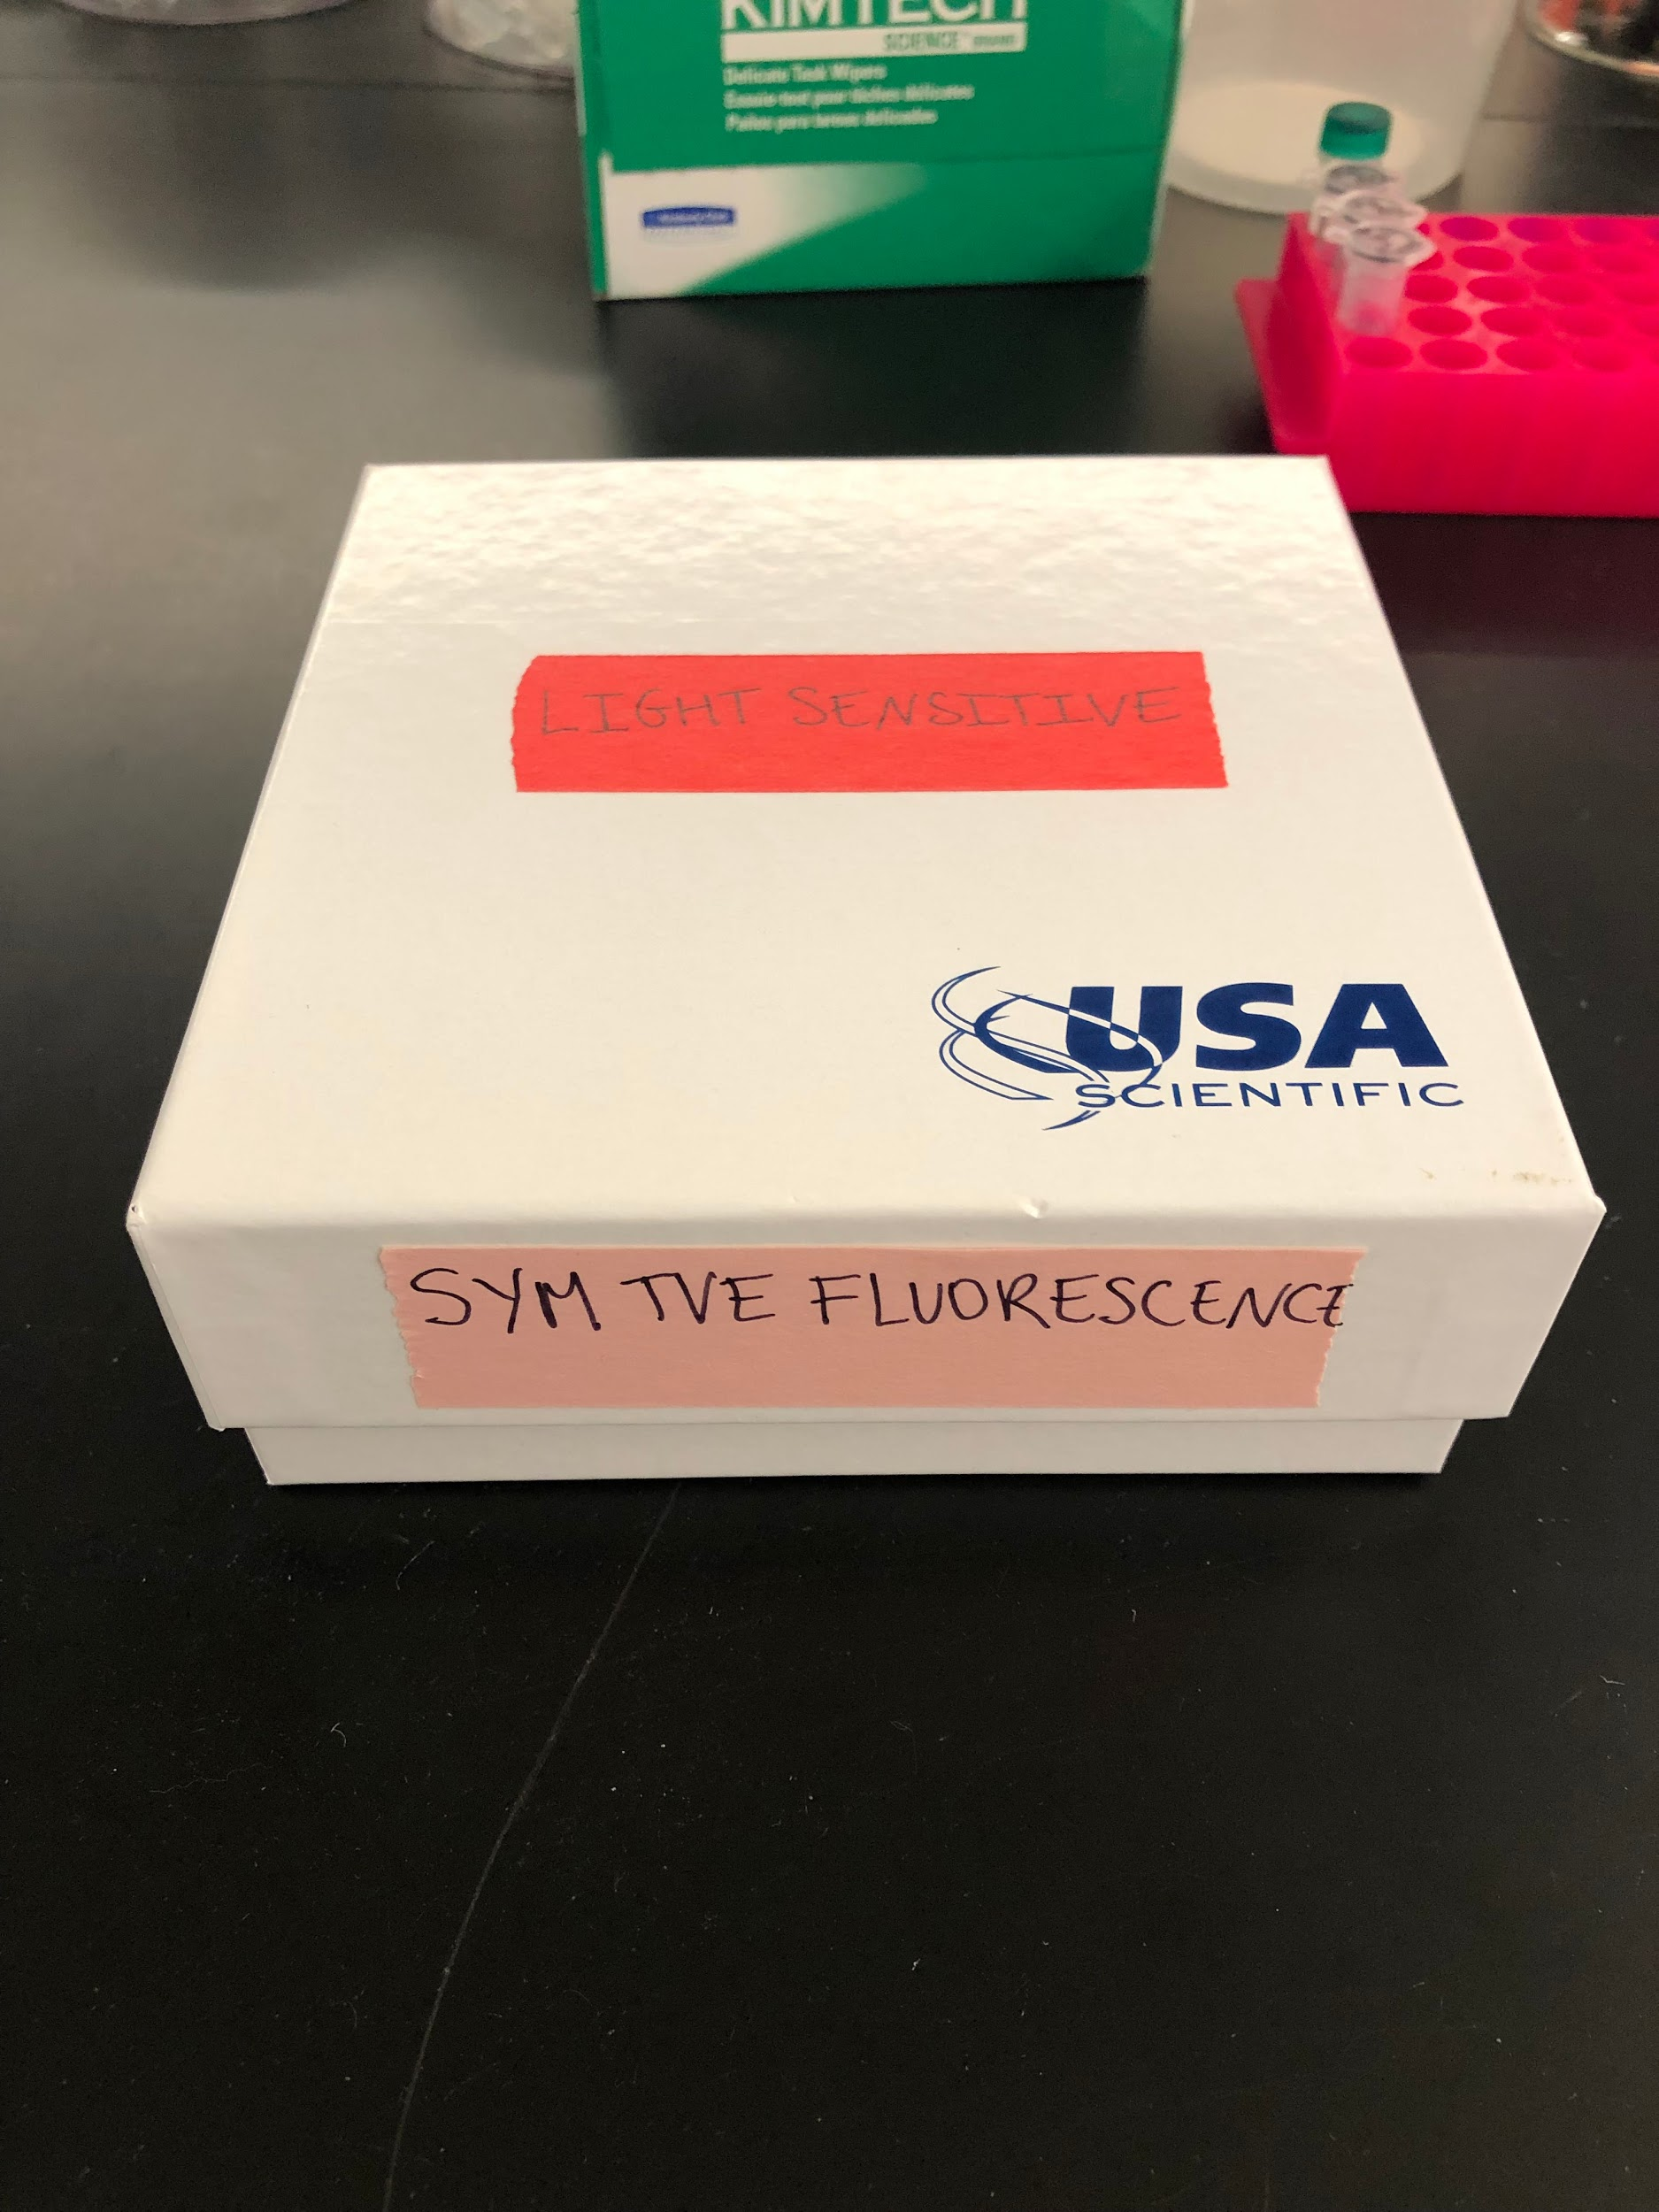
8. Immediately take 10µL of sample from lower third of tube and put on hemocytometer.
9. Let the sample settle for ~5 seconds before recording counts.
10. Record time of day, number of cells observed, and any notes such as contamination or cell lysis observed. Clean with D1 water, repeat steps 7-10 for 5 total replicates for each aliquot.
    1. Counting cells in central grid
    2. If cell is ~50% in the outer three lines, count it. If not, don’t

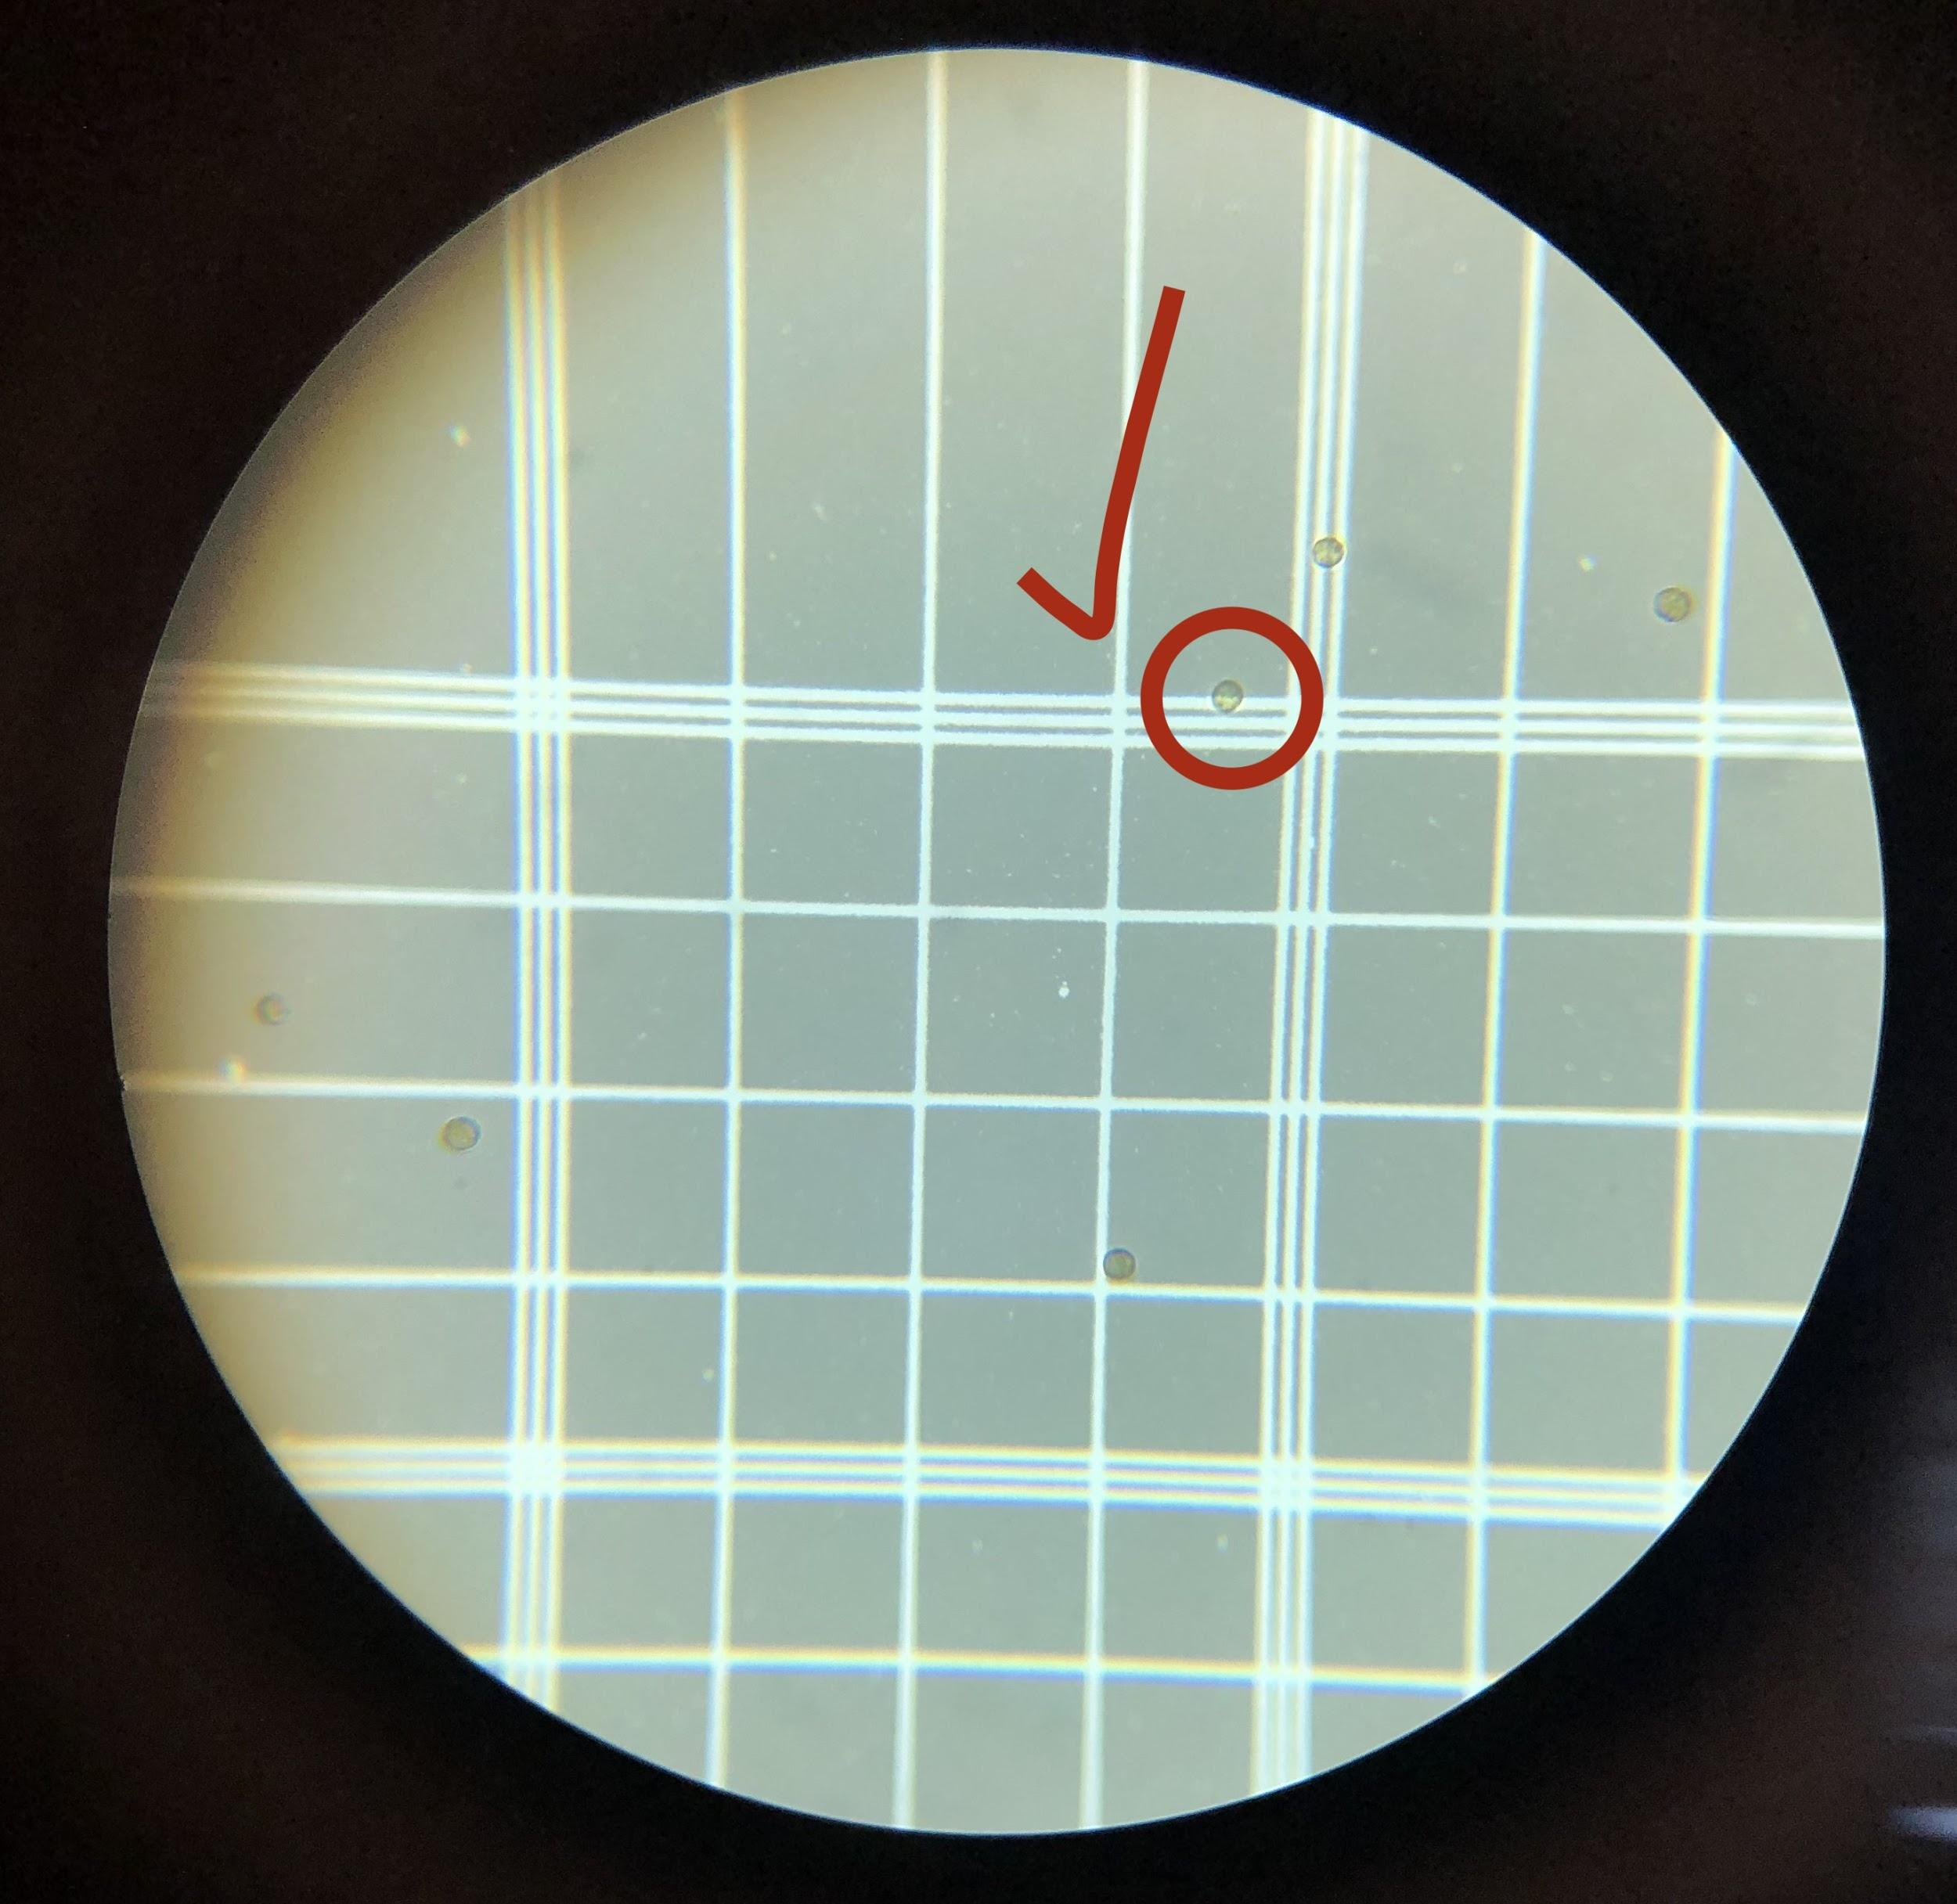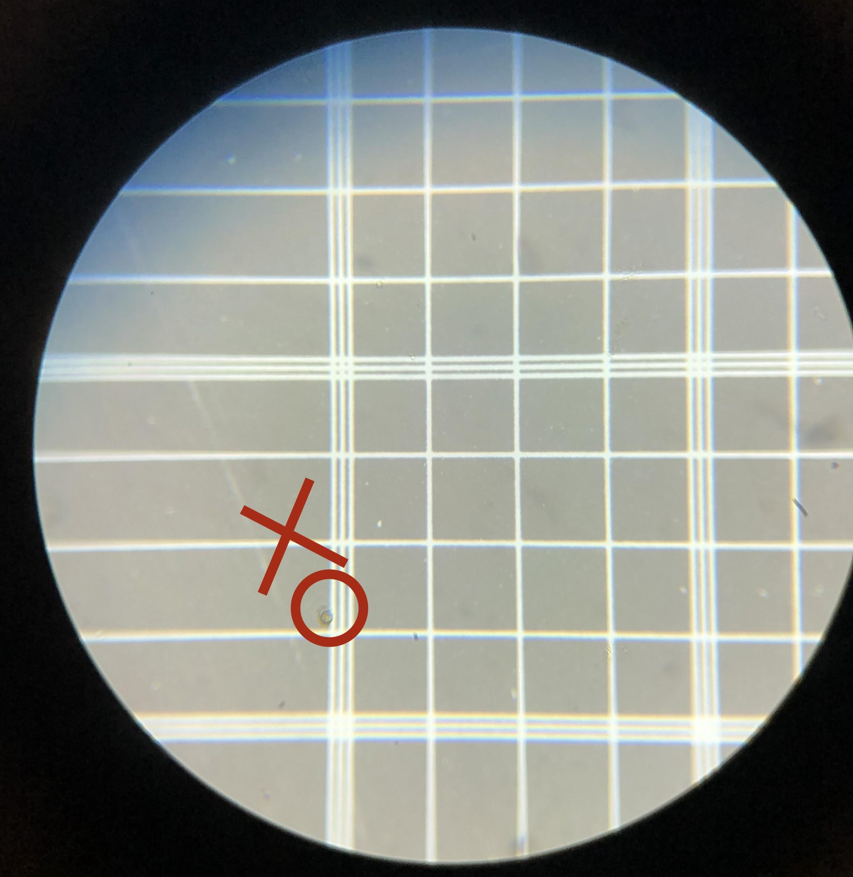

11. Once counts are completed, see Chlorophyll Extracts protocol (**If it is Wednesday, if not, dispose of samples).**